Assignment Task Tracker User Manual
Naomi Melnik (ID: 2892315) & Isaac James (ID: )
CIS 434
12/01/2025

Purpose
The purpose of this software is to allow specifically students (both secondary and postsecondary) to organize their assignments to stay on track. Students create an assignment by entering name, description, class label, due date, and priority level. Students are also able to sort their list by due date of the assignments.

The purpose of this user manual is to provide clear steps of how to launch and run the software along with navigating the features of the software.

Running / Launching the Software
Prerequisites: Java 22.0.2 or later, a functioning web browser
To run the program, download Tasker,jar file from github, then move it to a directory where you will not forget it. Double click on the .jar file to start running the program in the background. Navigate to your webbrowser, then enter http://localhost:8080 to your url bar, this will take you to the Add an Assignment form.

ADDING AN ASSIGNMENT

Input an assignment’s name, class, description, due date, and priority level (default level is set to low). If the due date field is left blank and you click ‘Add Task’ you will receive an error message and will not be able to create this assignment.
Error message will look like:
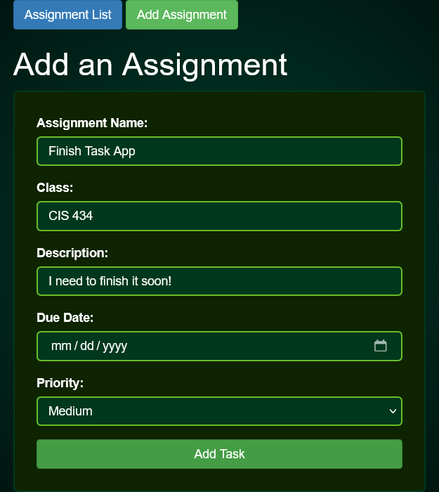
Once an assignment is successfully created, you will receive the following message:
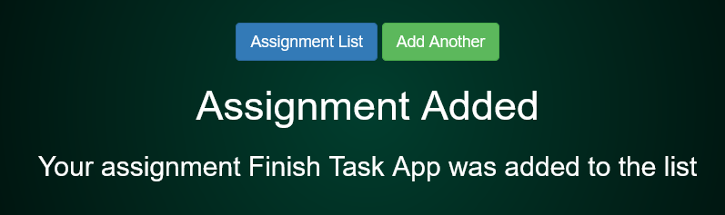
If you desire to add another assignment, simply click ‘Add Another’, or if you would like to view all of your assignments, click ‘Assignment List’.

ASSIGNMENT LIST

After clicking ‘Assignment List’, you will be directed to the following page. The page for assignment list consists of two navigation buttons at the top (1, 2) where you can select to add a new assignment (2). (3) Allows a user to select an option for how they want their list of assignments to be sorted. (4) is the different actions associated to an individual assignment from editing, deleting, and marking as complete.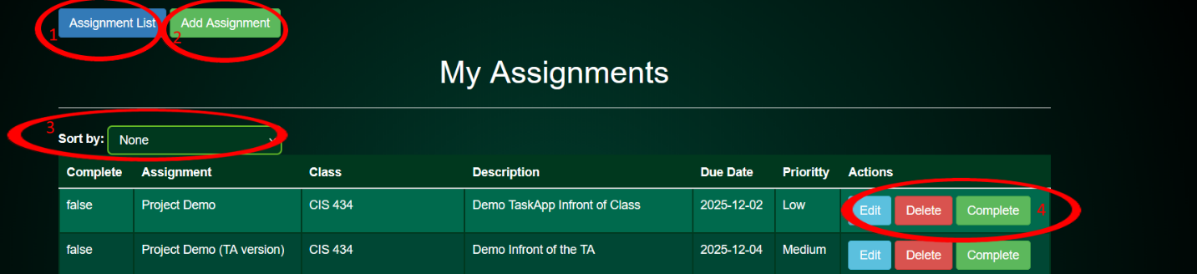

Editing an Assignment
If you wish to edit one of the assignment’s field (name, class, description, etc.), click the ‘Edit’ button in the row of the assignment you wish to edit. You will see the following:
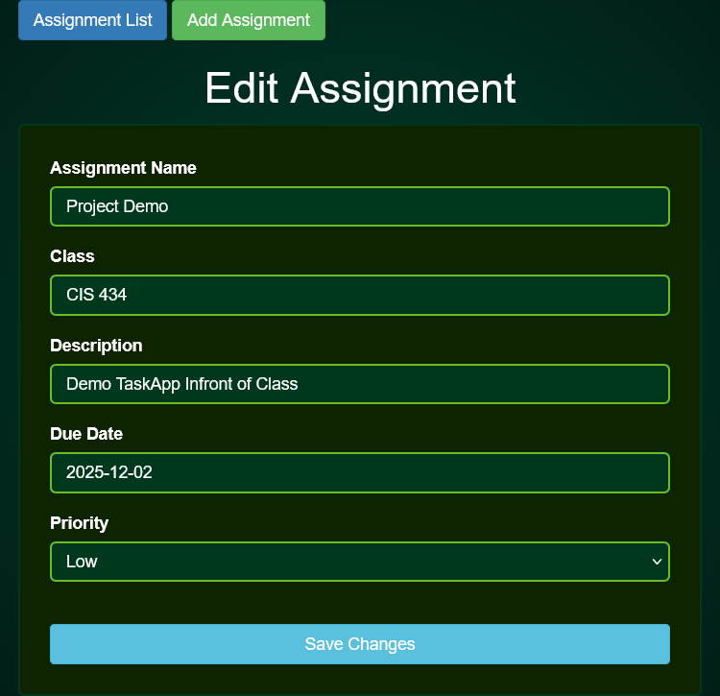
Once changes are made, click ‘Save Changes’ and your changes will be reflected in the table.
Deleting an Assignment
If you wish to delete an assignment, simply navigate to the assignment you wish to delete and select the delete button. Once the button is clicked, your assignment will be deleted from the list and no longer visible. This cannot be undone.

Marking an Assignment Complete
Once an assignment is completed, simply click the ‘Complete’ button in the assignment row. Once clicked, the following will be seen:
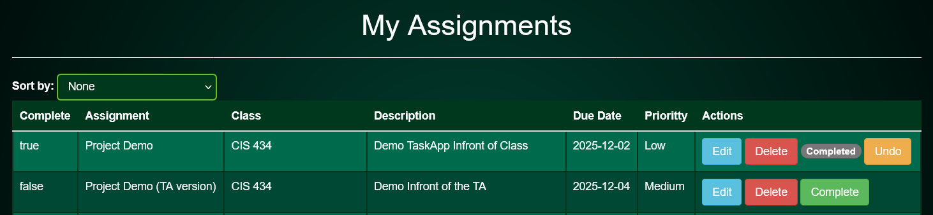
If the ‘Complete’ button was clicked by mistake, simply click the ‘Undo’ button to show the assignment still needs to be completed.
Sorting the List
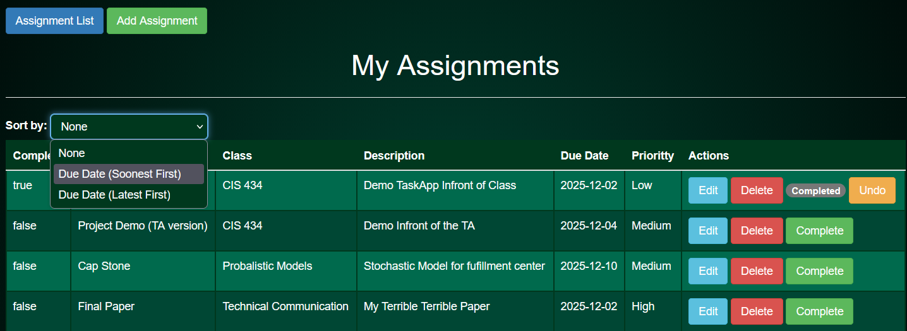

By clicking the drop down by ‘Sort by:’ you can select if you want your list sorted by the assignments due soonest or latest. Upon selecting, you will see your listed sorted accordingly.

